Name- Aarya Tiwari

Roll no. – 16010421119

Division – SY IT B

Programming Laboratory – 1

Tutorial 1

**Problem Statements:-**

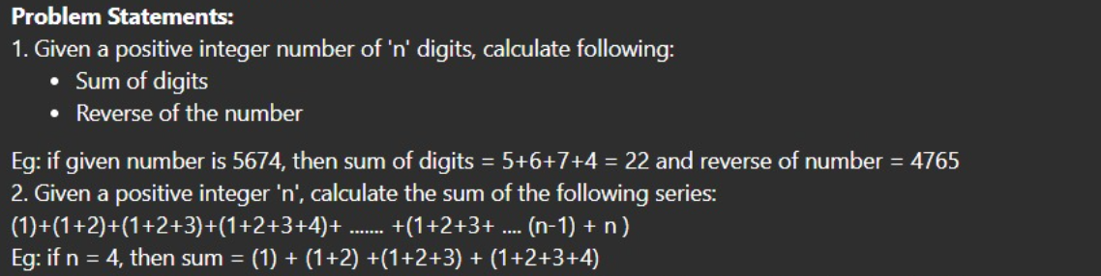

Part 1:-

Implementation details:-

#include<iostream>

#include<math.h>

// Part 1(a)

using namespace std;

int main()

{

    int choice;

    int sum = 0;

    int remainder ;

    cout<<"Enter a number: ";

    cin>>choice;

    while(choice > 0 )

    {

        remainder = choice % 10;

        sum = sum + remainder;

        choice = choice / 10 ;

    }

    cout << "The sum of the digits is: "<<sum<<endl;

    return 0;

}

Output:-

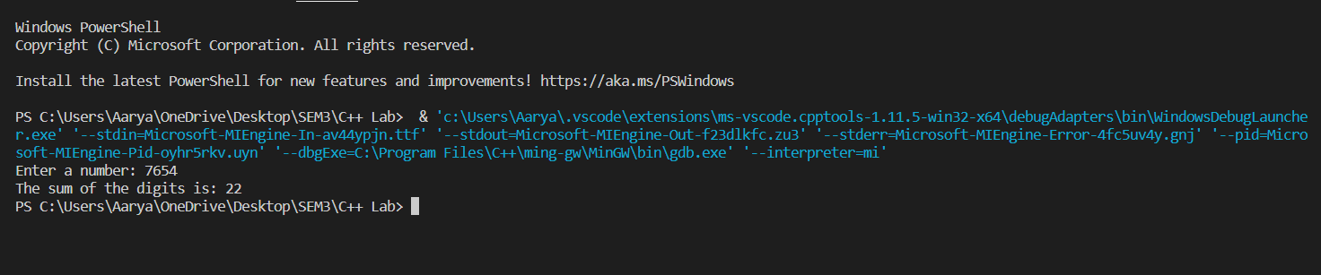

Implementation 2:-

#include<iostream>

#include<math.h>

// Part 1(b)

using namespace std;

int main()

{

    int reverse = 0 , choice, remainder  ;

    cout<<"Enter a number: ";

    cin>>choice;

    while (choice>0)

    {

        reverse = reverse*10 + choice%10;

        choice /= 10;

    }

    cout<<"Reverse of the number is: "<<reverse;

}

Output:-

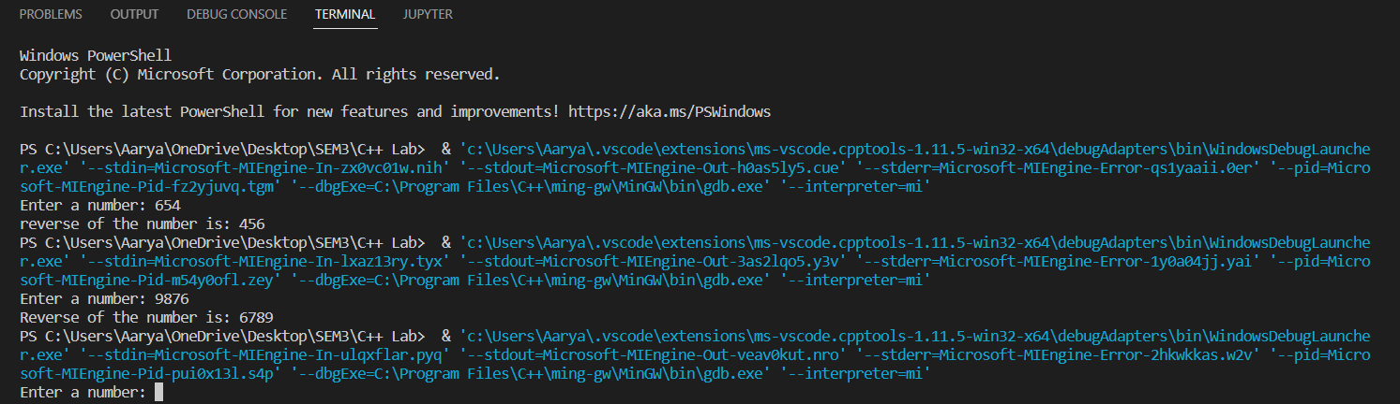

Part 2:-

Implementation:-

#include<iostream>

#include<math.h>

// Part 2

using namespace std;

int main()

{

    int choice,sum = 0;

    cout<<"Enter a number: ";

    cin>>choice;

    for (int i = 1;i<=choice;i++)

    {

        sum = sum + i;

    }

    cout<<"The sum of the numbers is: "<<sum;

}

Output:-

